**Review Worksheet – *Australopithecus***

1: How long ago did *Australopithecus* live and where could it be found?

(2 marks)

*Australopithecus lived around 3-4 million years ago (1) in East Africa (1).*

2: Describe the habitat and behaviour of *Australopithecus*\*.

(9 marks)

*Australopithecus evolved during a period of climate change (0.5), when forests were getting smaller grassland was getting larger (0.5). They were bipedal (0.5), but spent some time in trees and some time on the ground (0.5). They lived in family groups (0.5) and had a mostly vegetarian diet (0.5). They used sticks and rocks to forage for food (0.5), and may have made very simple stone tools (0.5). There is no evidence that they used fire, built structures, made art, or had language or abstract thought (0.5).*

3: What aspects of the fossil record show us that *Australopithecus* were bipedal?

(3 marks)

*The Laetoli footprints (0.5) show a platform foot (0.5), with aligned big toe (0.5) and heel to toe gait (0.5).*

*The “Lucy” skeleton (0.5) shows the short, broad pelvis (0.5) and carrying angle (0.5) associated with bipedalism.*

4: What aspects of Australopithecine dentition shows that they are likely to be human ancestors?

(4 marks)

*Australopithecines show movement towards a parabolic dental arcade (1). Their canines are reduced in size (1) compared to apes and are not prominent (1). There is a small to absent diastema (1).*

5: What does Australopithecine dentition tell us about their diet?

(2 marks)

*They have large molars (1), indicating a diet with hard plant matter that needed to be chewed (1).*

6: Which of the following skulls is likely to be from an *Australopithecus?* Describe the features that helped you to make the identification. Hint: the other skulls shown are chimp, human and *Paranthropus*.

(4 marks)

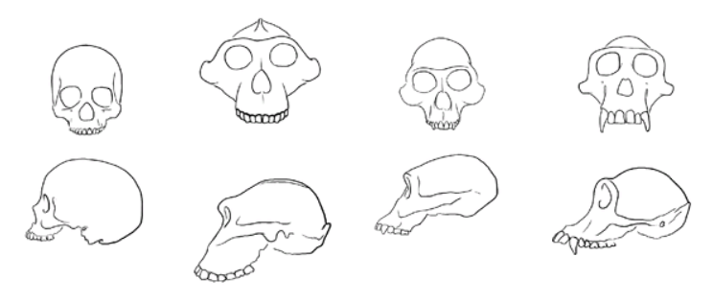

*1 mark for correct identification. 3 marks for any 3 features including:*

* *Large cheekbones for muscle attachement*
* *Small canine teeth*
* *Small cranial capacity*
* *Skull slopes back from eye sockets*
* *Prominent brow ridges*

7: What features of skull and dentition of *Australopithecus africanus* indicate that it is probably more closely related to humans than the earlier *Australopithecus afarensis*?

(2 marks)

*Skull: slightly larger cranial capacity (0.5), more arched forehead (0.5), smaller brow ridges (0.5).*

*Dentition: smaller incisors and canines (0.5), no diastema (0.5).*

8: You are a paleoanthropologist, working in the Rift Valley of East Africa. A skull is brought to you by one of the University students you supervise. They want to know whether you think it is the skull of an *Australopithecus,* or of *Paranthropus.* List features that would make you think the skull was from *Paranthropus.*

(3 marks)

* *Larger, thicker skull*
* *Sagittal crest*
* *Very large jaw and cheek bones for muscle attachment.*

9: a) When an inhibitory neurotransmitter binds to the post-synaptic receptors,

what are the possible effects on the gated channels of the post-synaptic membrane, and what is the resultant effect on the membrane potential and propagation of the action potential?

(6 marks)

*It causes either K+ gates to open (1), allowing K+ to move out of the post-synaptic neuron (1), or it causes Cl- gates to open (1) causing Cl- to move in to the post-synaptic neuron (1). In both cases, the membrane potential becomes increasingly negative (hyperpolarisation) (1), meaning that it is harder to reach the threshold for a new AP to be generated. (1)*

b) What does this mean for the speed of transmission?

(1 mark)

*It will be slowed (0.5) or stopped (0.5)*